1. We only need to give a counter example: Consider the following schema; a b c and c->b Clearly the above schema is in 3NF, because ab->c is a superkey dependency and ,from c->b we can see that b-c=b, which is a subset of the primary key (such dependency is also allowed in 3NF). But, the above schema is not in BCNF because c->b is neither super-key nor trivial dependency. So we decompose above schema , keeping it lossless. Only possible lossless decomposition is: ac and cb. (because,their intersection c is primary key for the 2nd table). But clearly the dependency ab->c is lost.

2)

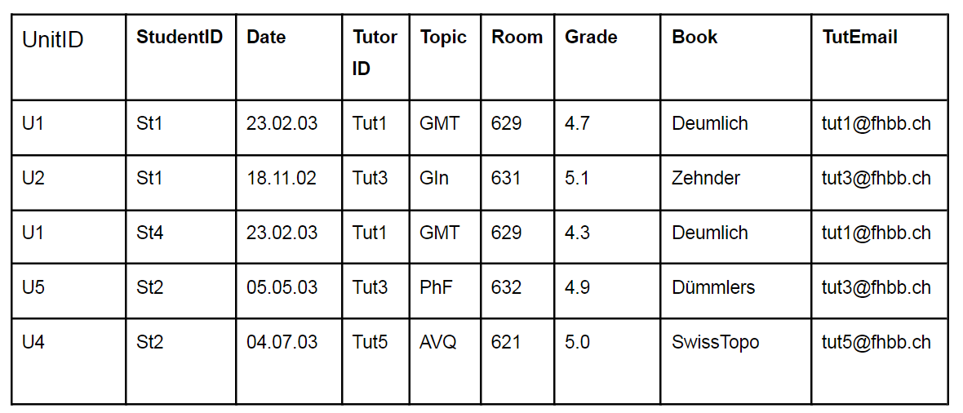

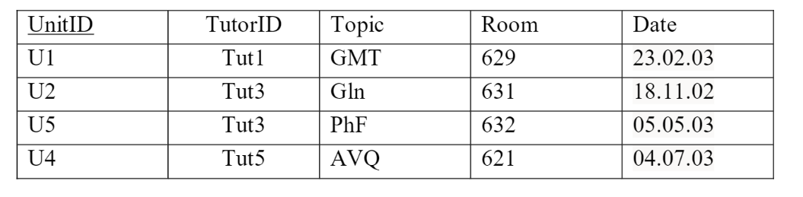

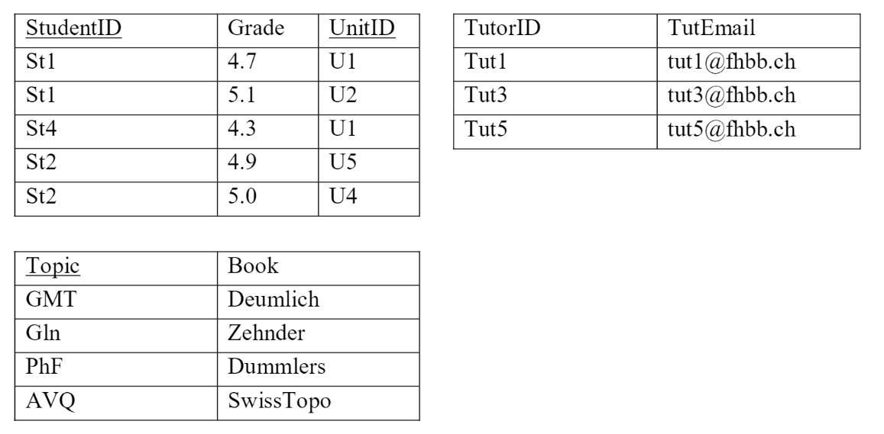

3)

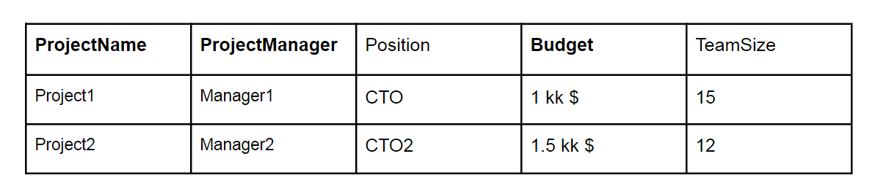

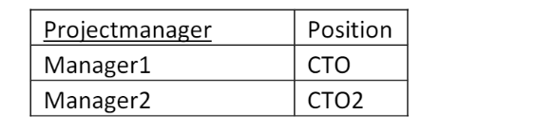

4)

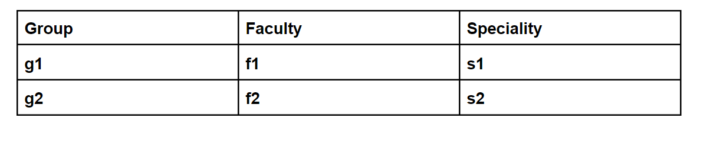

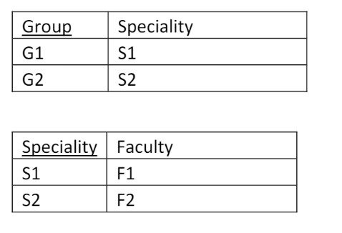

5)

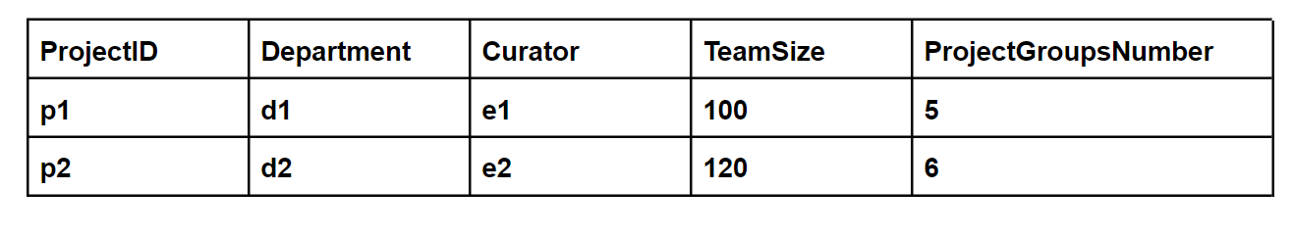

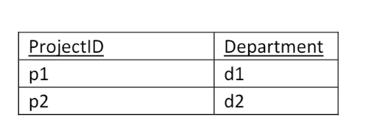

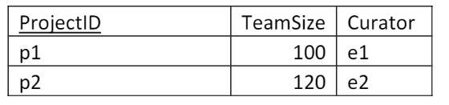

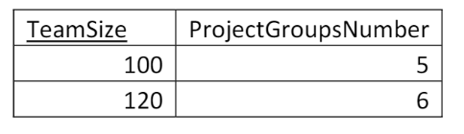

6)

desirable type : Lossless Decomposition

undesirable type : Lossy Decomposition

The three design goals are lossless-join decompositions, dependency preserving decompositions, and minimization ofrepetition of information. They are desirable so we can maintain an accurate database, check correctness of updates quickly, and use the smallest amount of space possible.